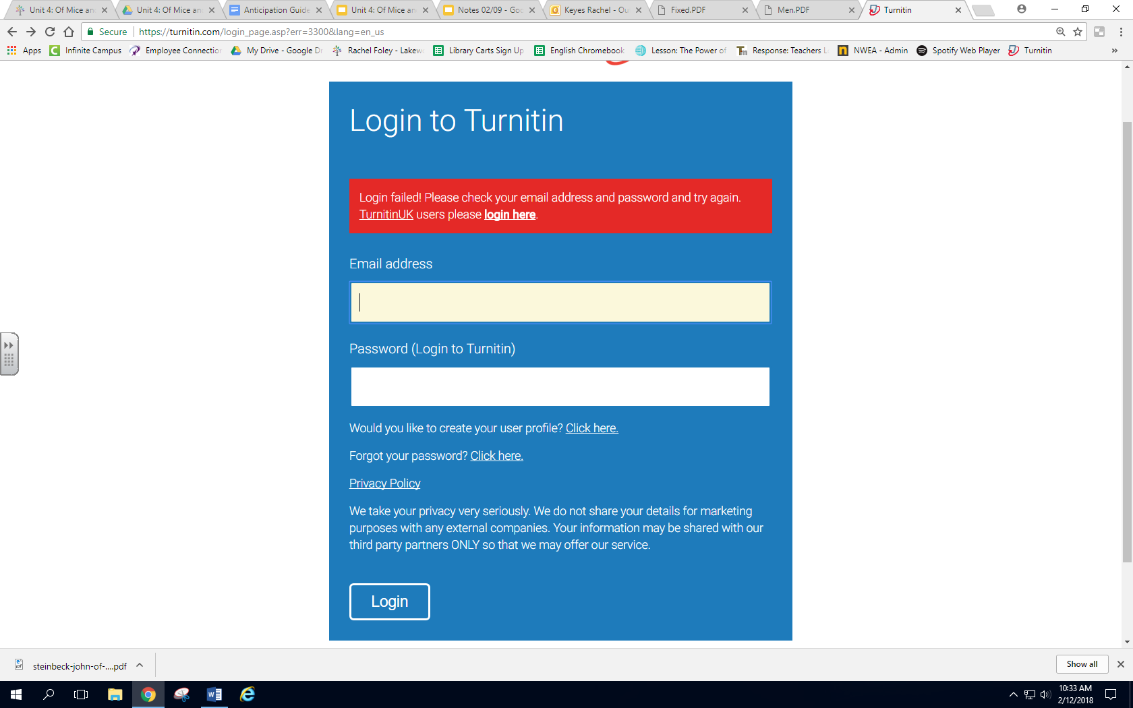

**Turnitin.com-Creating your Account**

**Creating your User Profile**

Step 1: Go to [Turnitin.com](https://turnitin.com/login_page.asp) and click to create your user profile

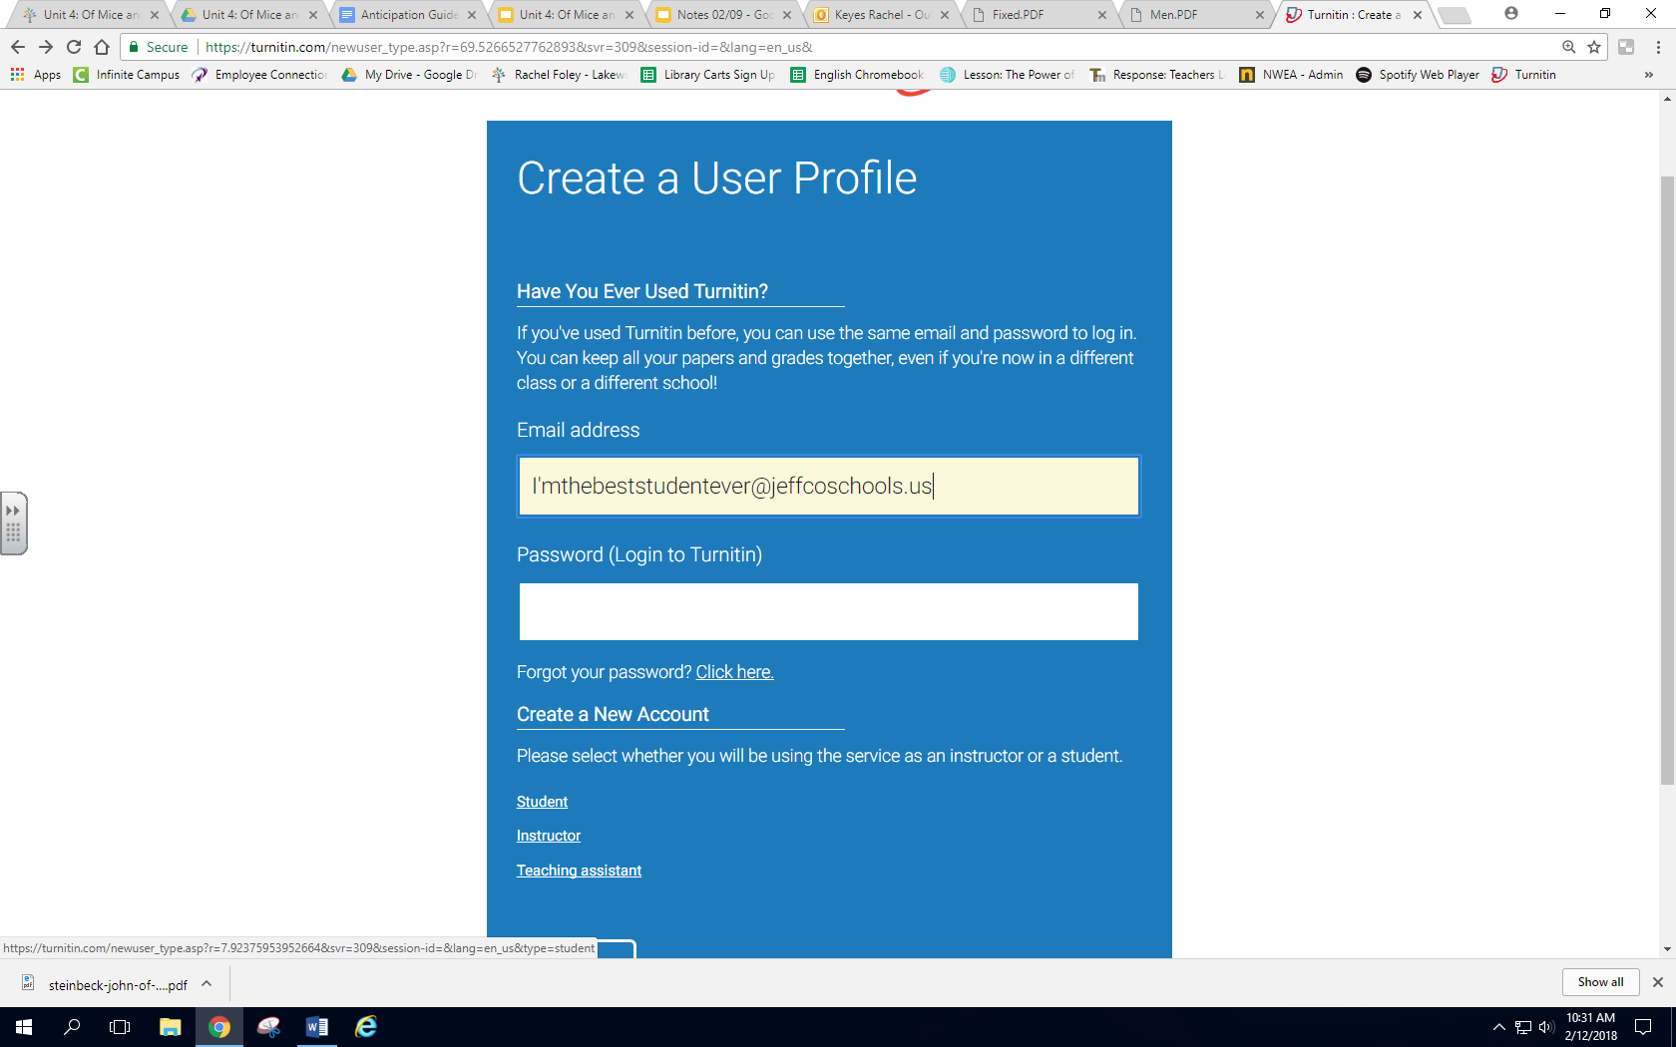

**Creating your User Profile**

Step 2: click student

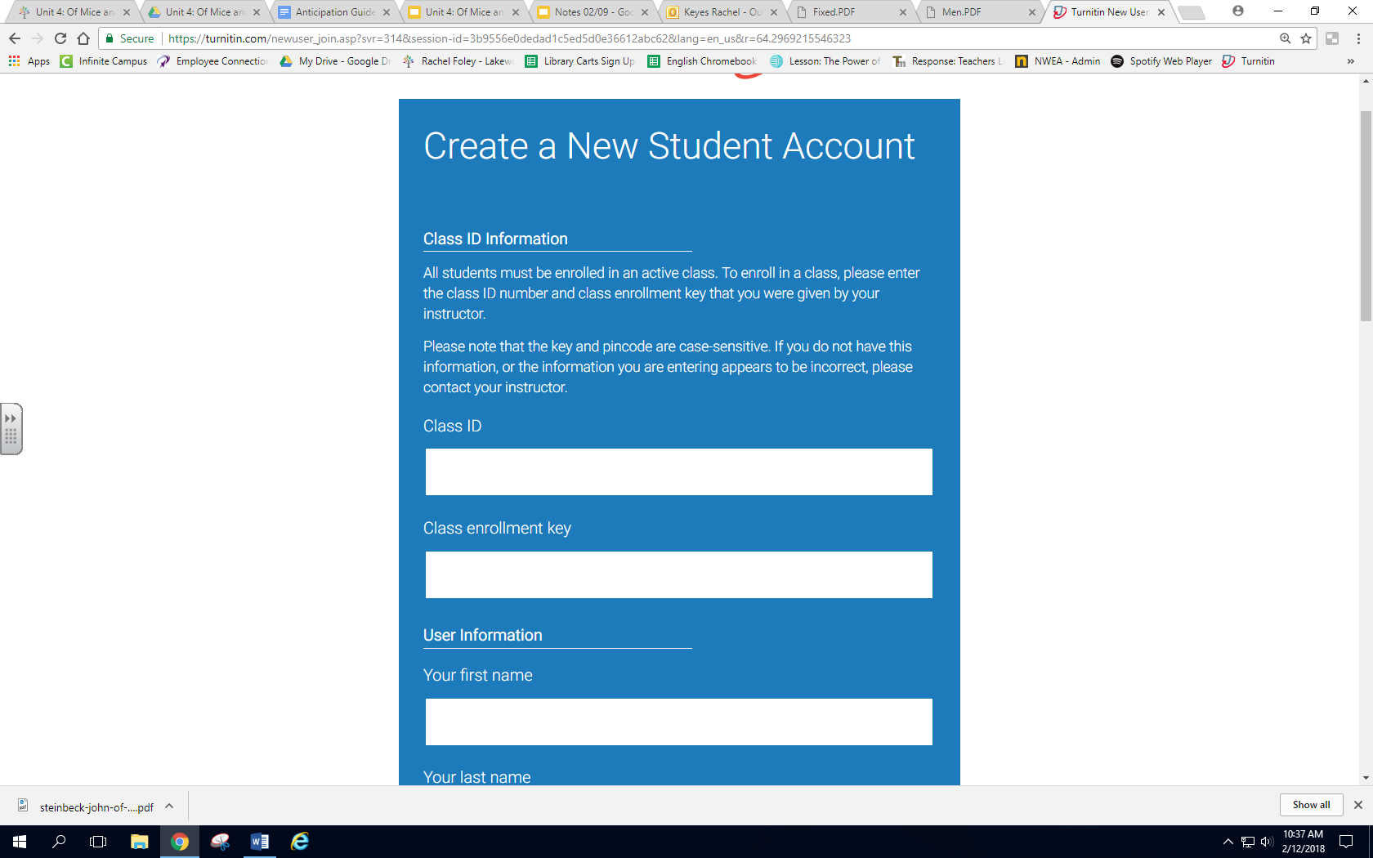

123456

98765

**Creating your User Profile**

Step 3: Enter in the Class ID and Class Enrollment Key given to you by your teacher

Example:

Class ID🡪 123456

Class Enrollment Key🡪 98765

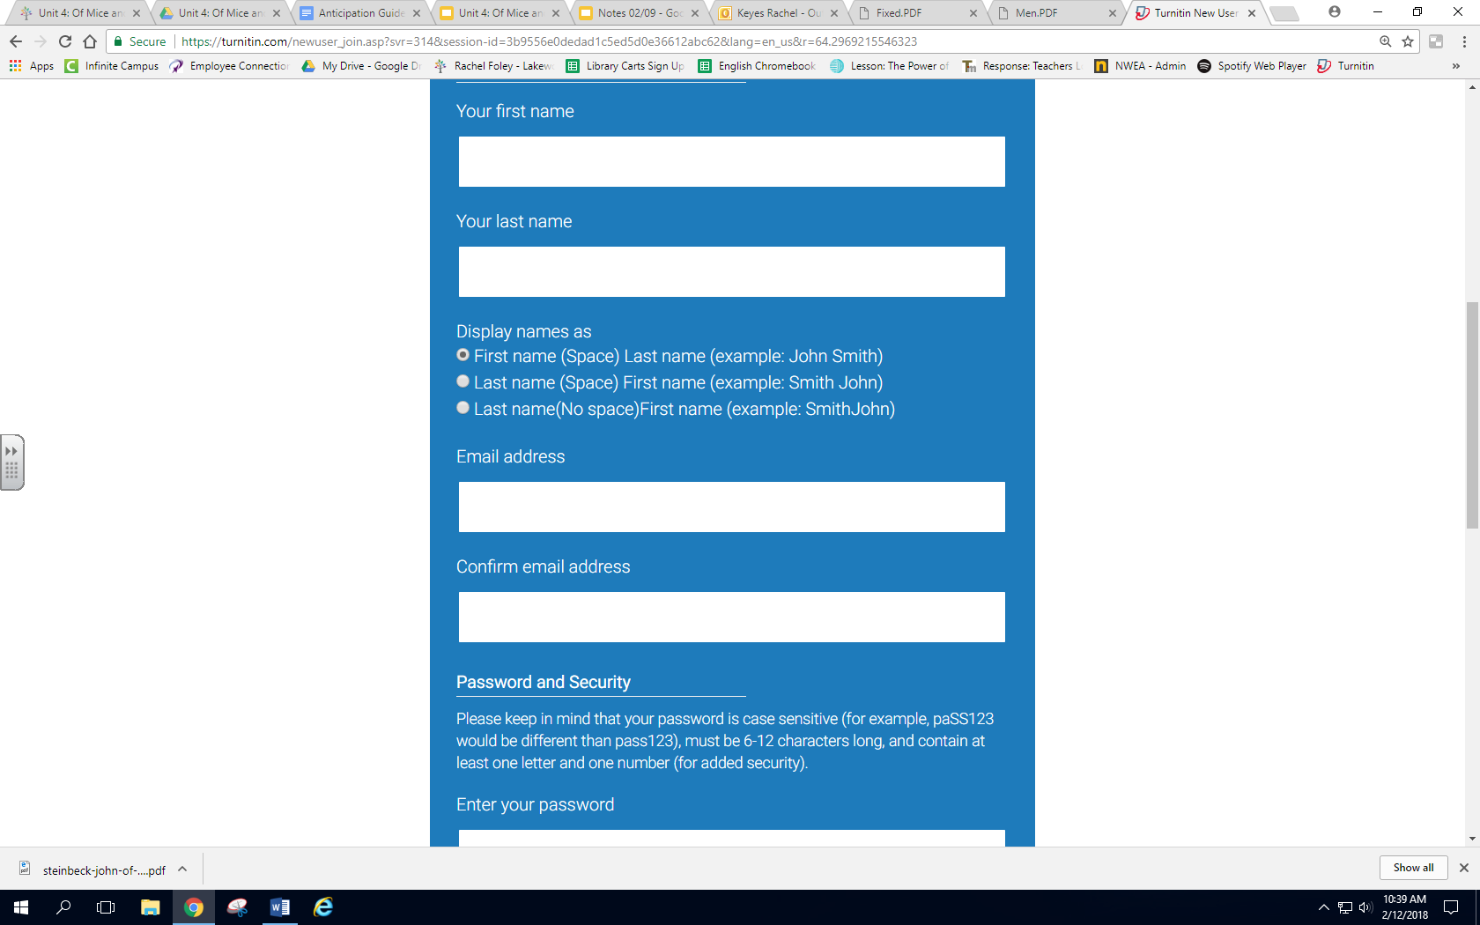

rkeyes@jeffcoschools.us

Rachel

Foley

rkeyes@jeffcoschools.us

**Creating your User Profile**

Step 3: Enter in your personal information

YOUR EMAIL MUST BE YOUR JEFFCO EMAIL

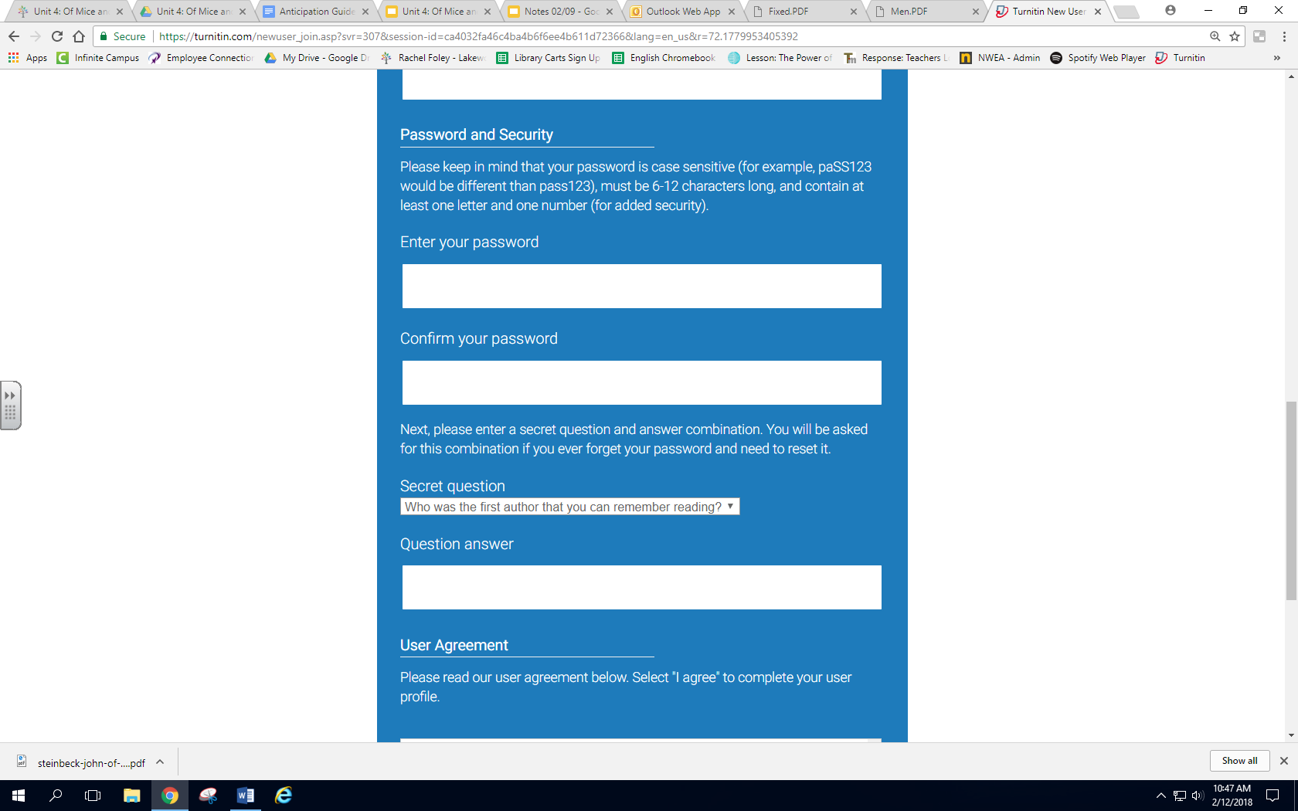

Password

Password

**Creating your User Profile**

Step 4: Create a password

YOUR PASSWORD SHOULD BE THE SAME ONE YOU USE TO LOGIN TO JEFFCO

Select a security question to answer

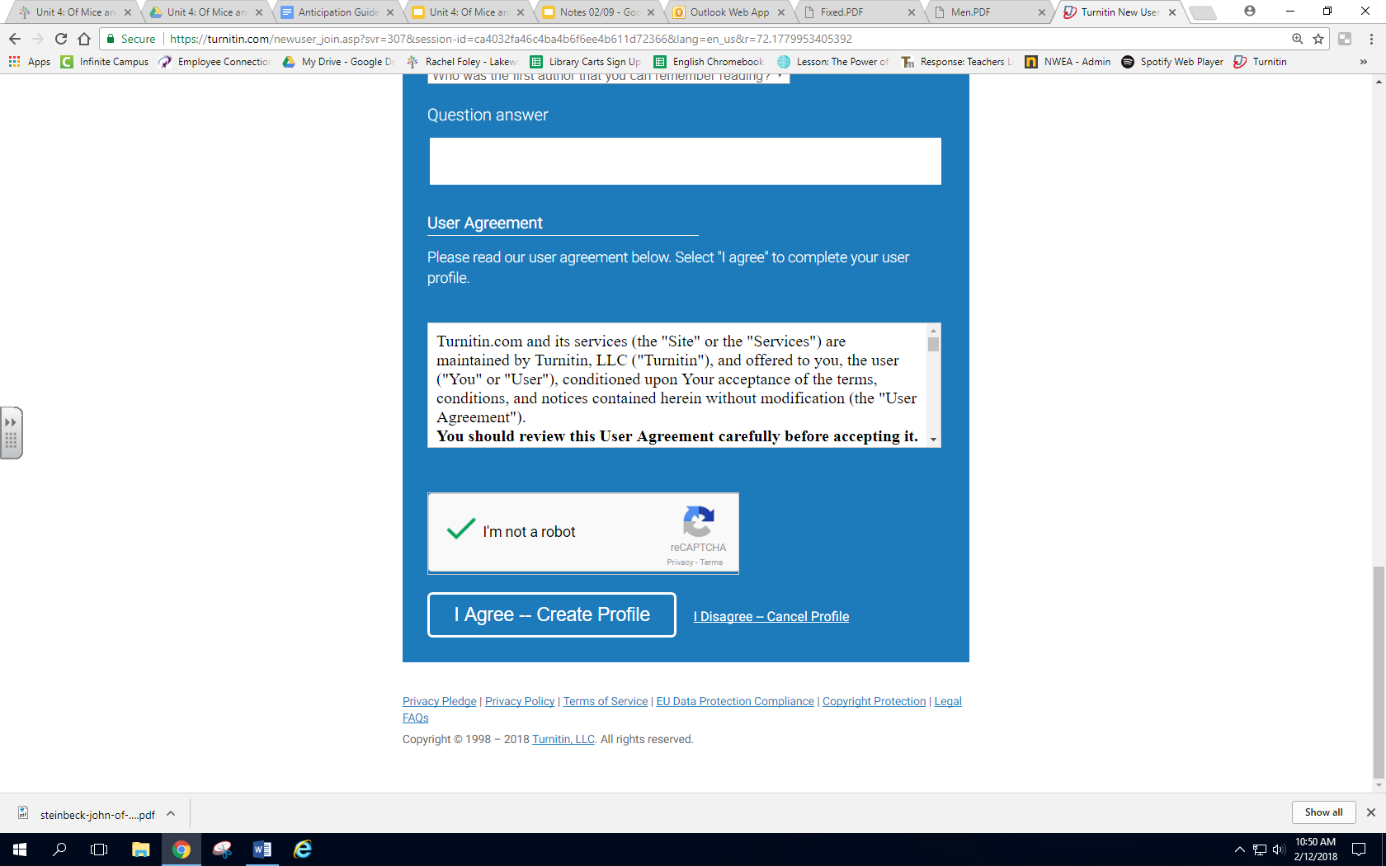

**Creating your User Profile**

Step 5: Create Profile

Read over the user agreement and click the agree button.

MAKE SURE YOU CHECK THE “I’M NOT A ROBOT BOX” If you forget to do this, you will have to reenter all of your information

Tamora Pierce

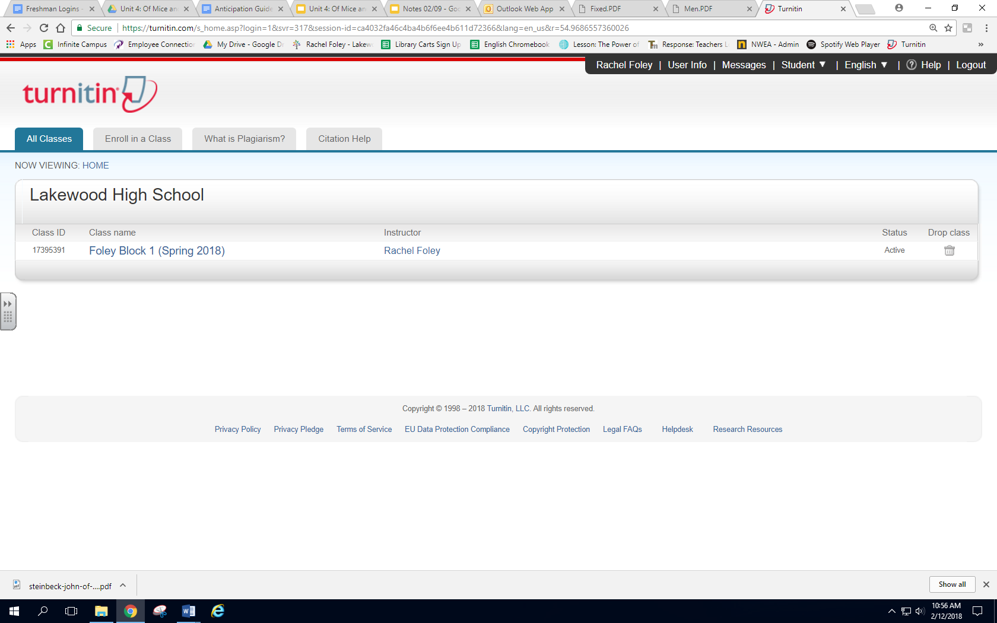

When finished, you should see this screen, with your class name.

Congratulations, you’ve created your account!