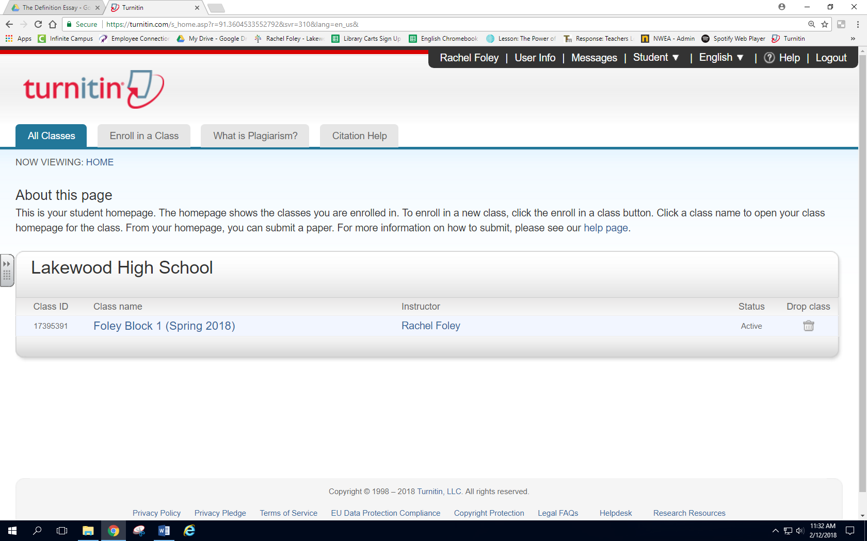

**Turnitin.com- Enrolling in a new class**

**Enrolling in a new class**

**Step 1:** From your home page, select “Enroll in a Class”

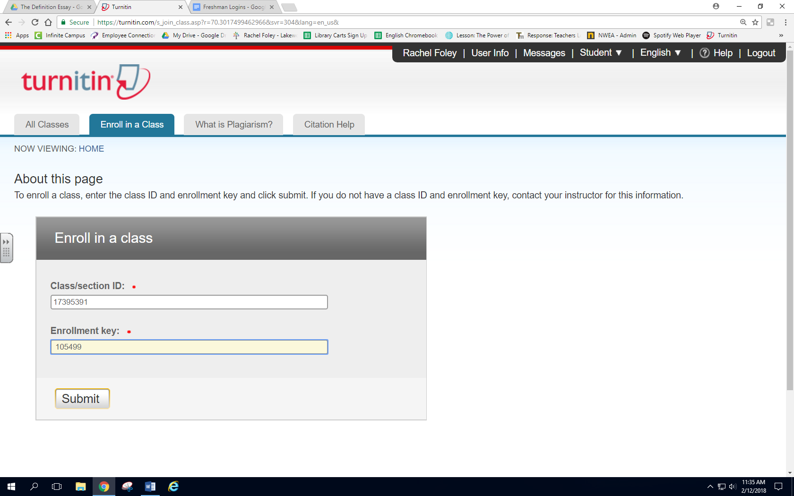

**Creating your User Profile**

**Step 2:** Enter in the Class ID and Class Enrollment Key given to you by your teacher

Example:

Class ID🡪 123456

Class Enrollment Key🡪 98765

**Step 3:** Click Submit

123456

98765

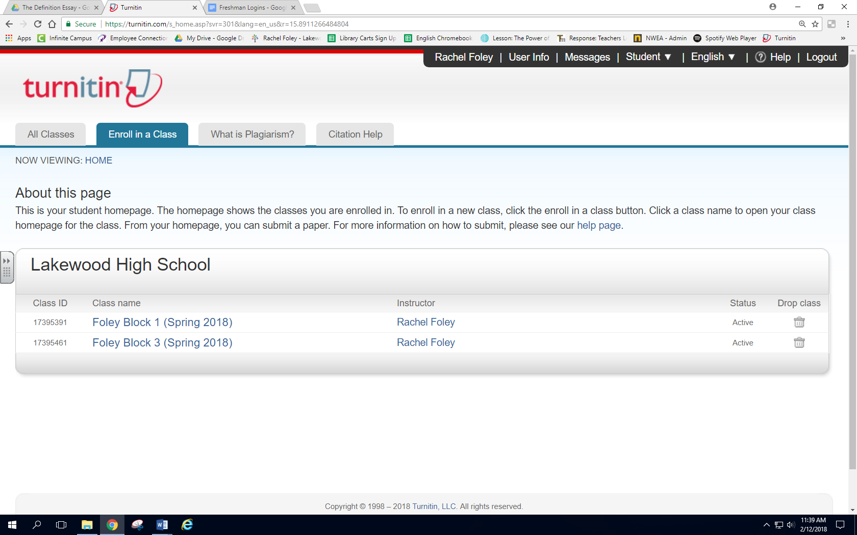

You should now see you new class on your home page!