**Turnitin.com- Submitting an Essay**

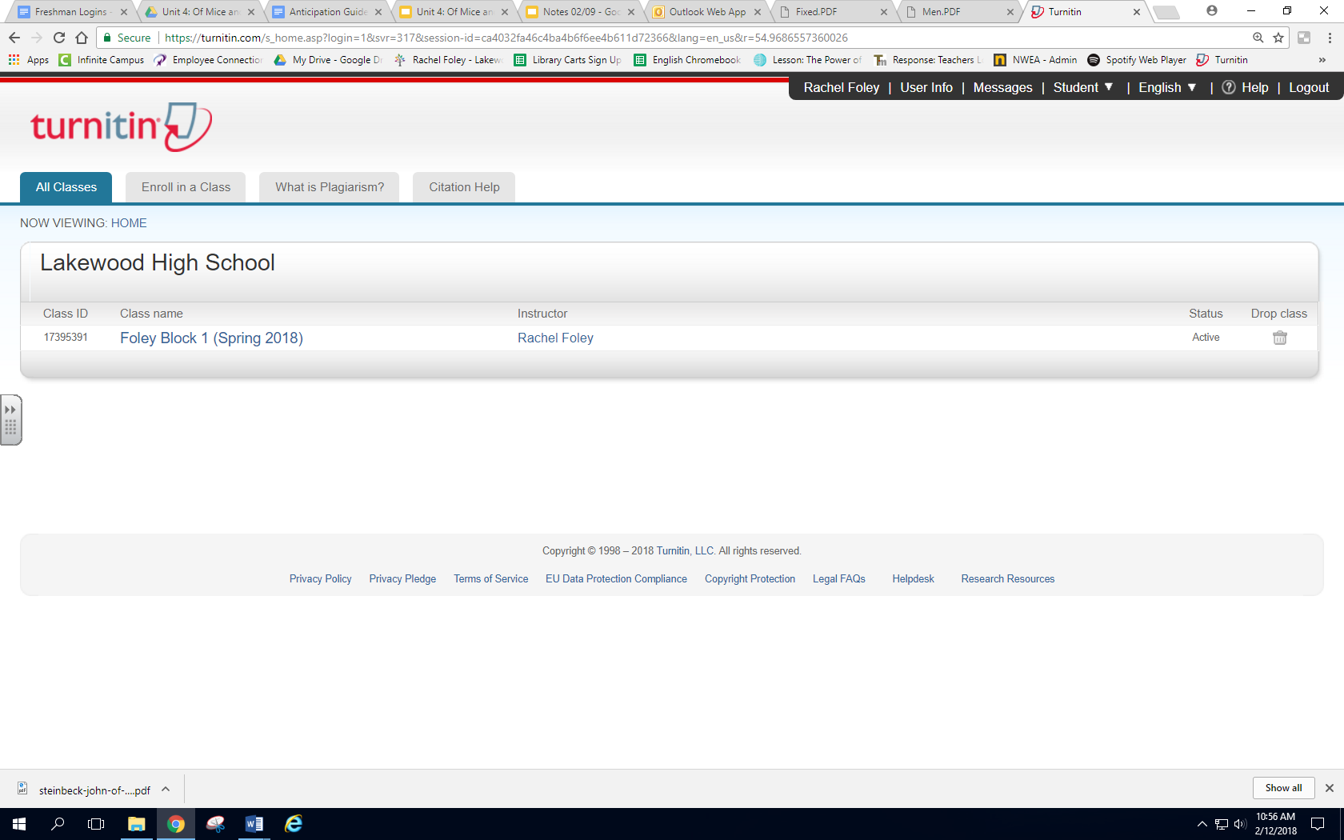

**Submitting an essay**

**Step 1:** Select your class

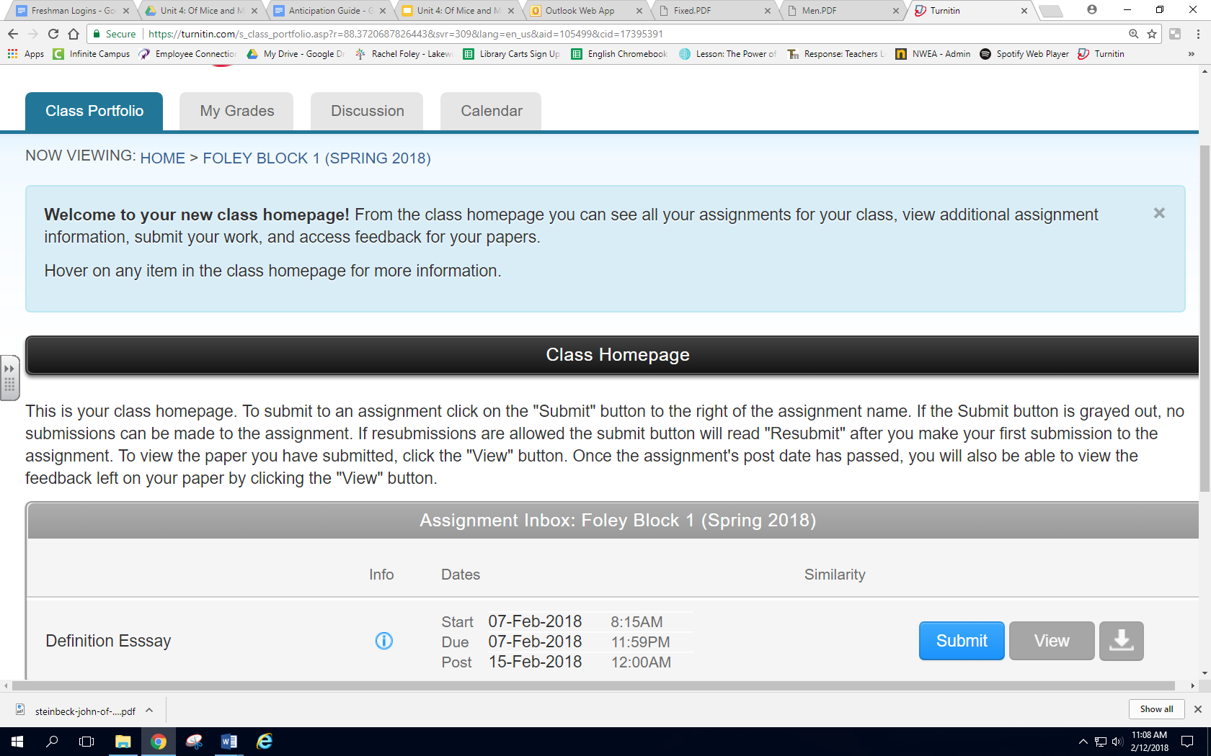

**Submitting an essay**

**Step 2:** Find your assignment that needs to be turned in on the Class Homepage. Select the blue “Submit” button

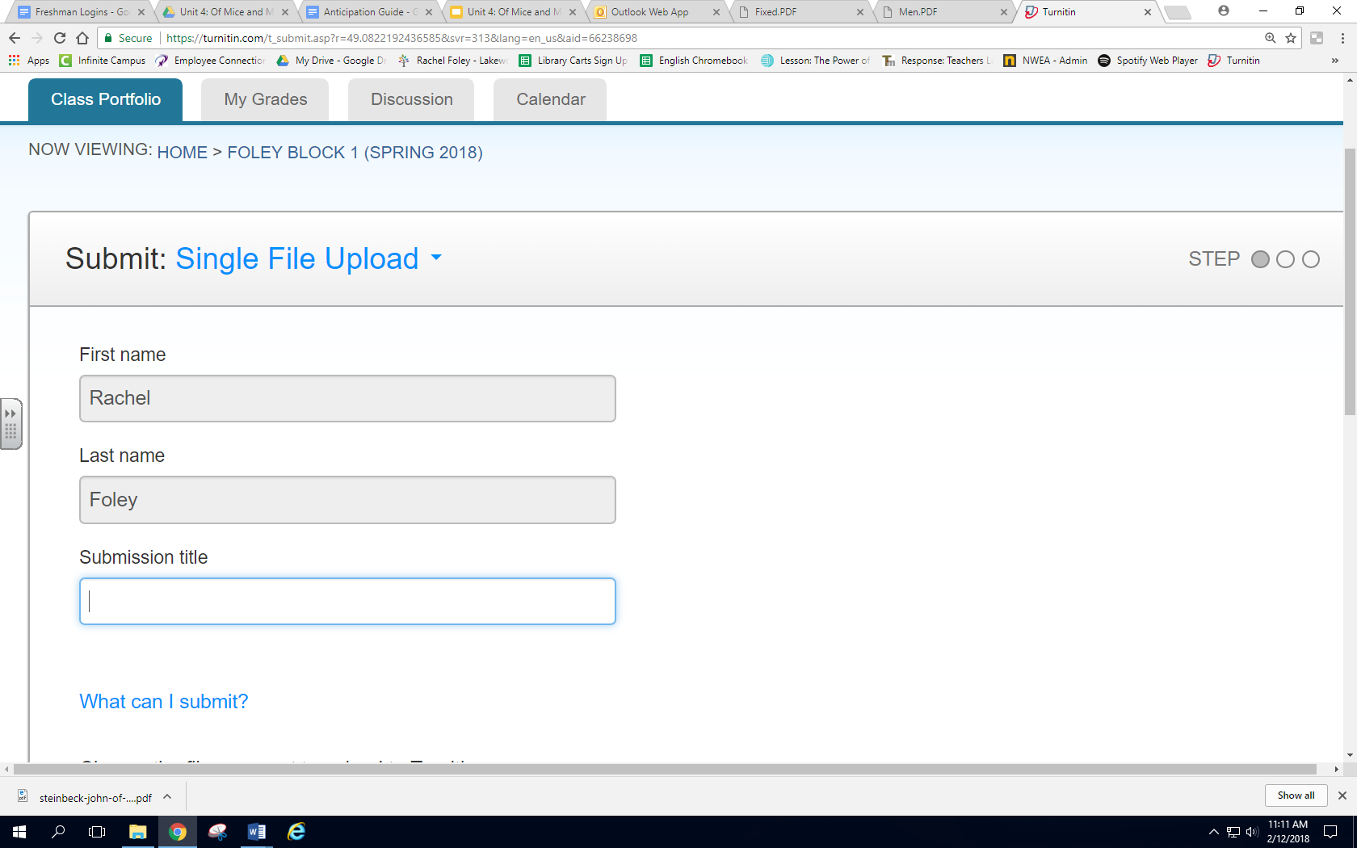

**Submitting an essay**

**Step 3:** Make sure it says “Single File Upload” at the top (If it says “cut and paste”, click it and select “single file upload”.

**Step 4:** Give your essay a title

Foley Definition Essay

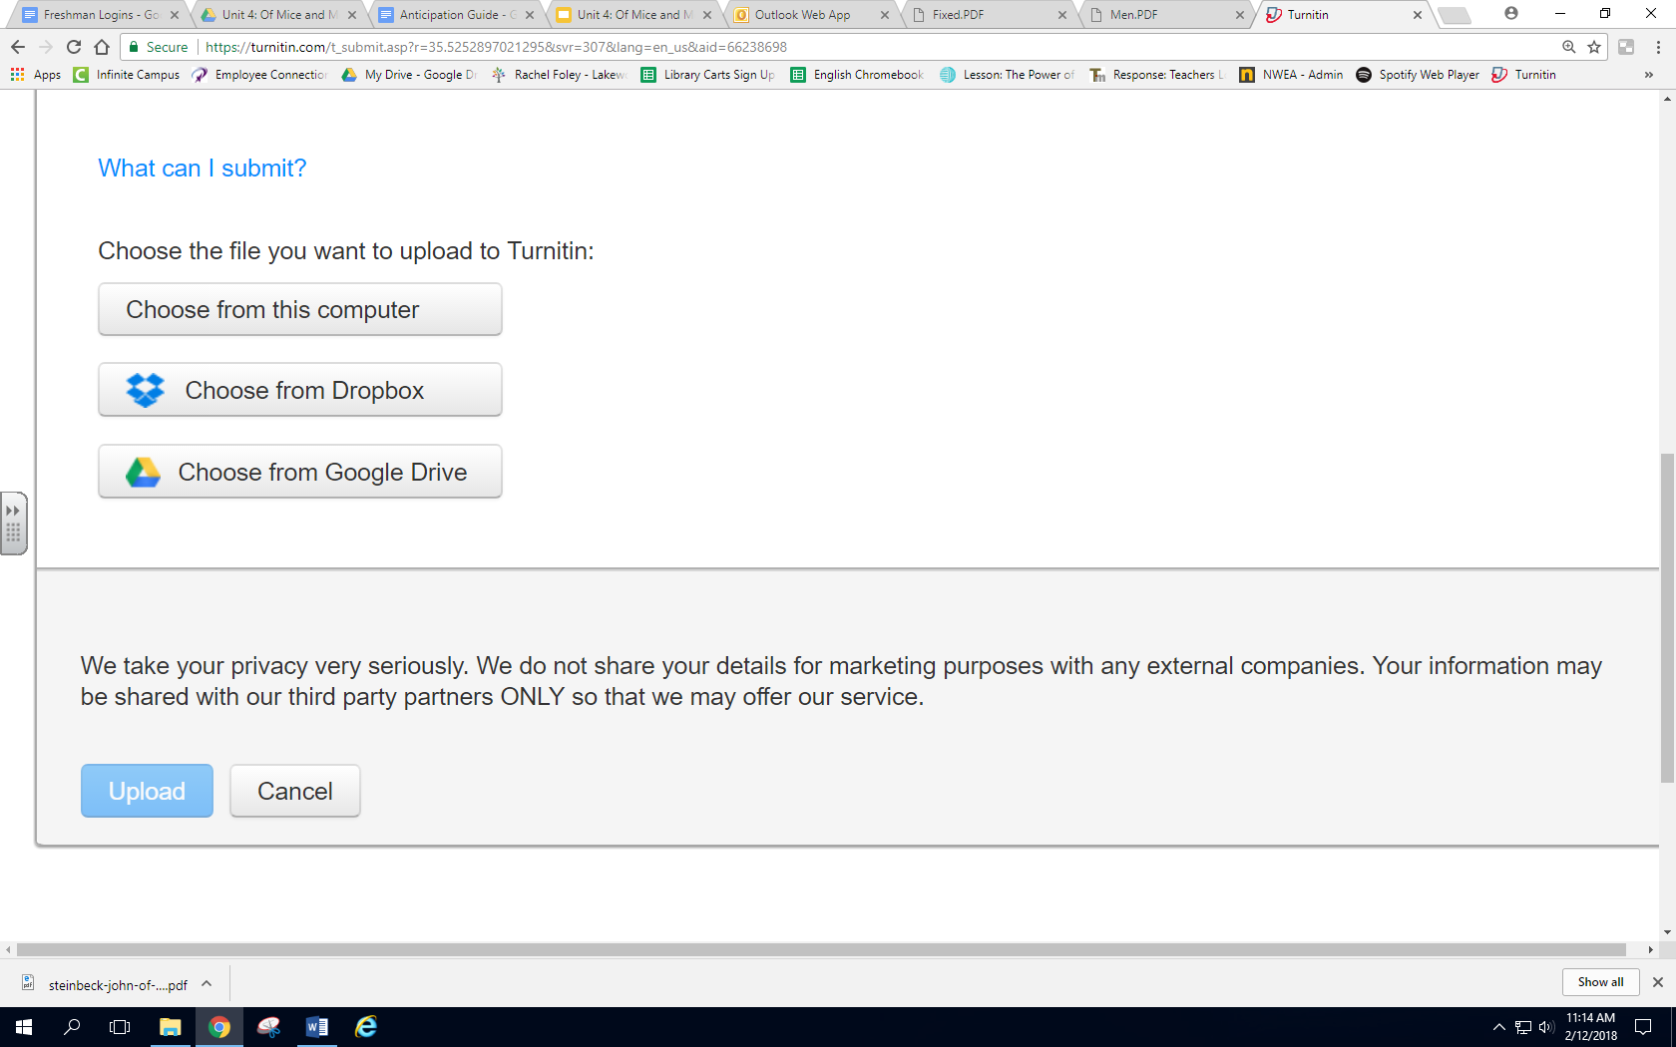

**Submitting an essay**

**Step 5:** Select “Choose from Google Drive”

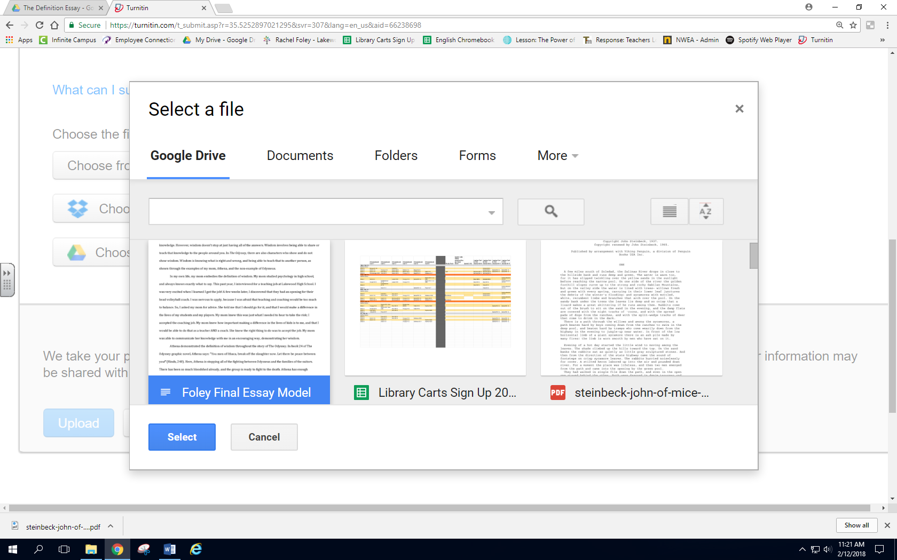

**Submitting an essay**

**Step 6**: Select your essay from your Google Drive, and then press the select button. (If you cannot press select, make sure you have clicked on your essay

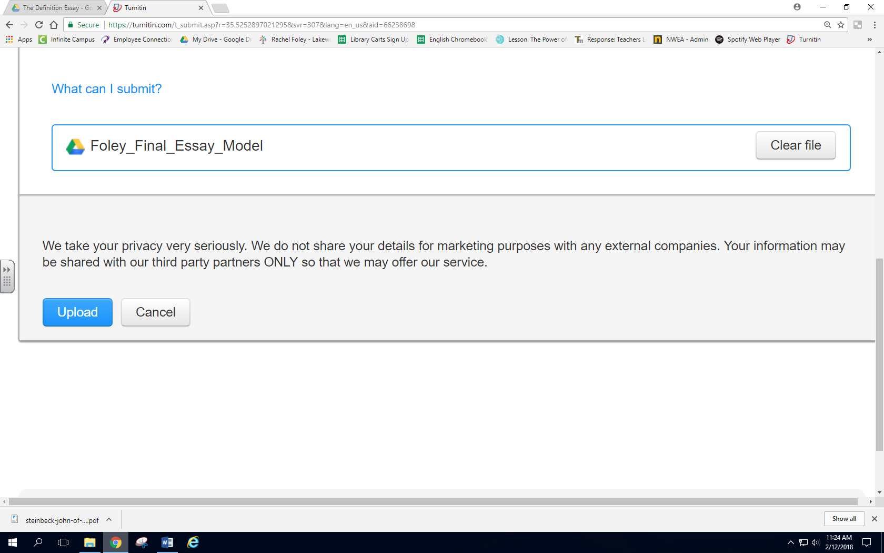

**Submitting an essay**

**Step 7**: Select upload

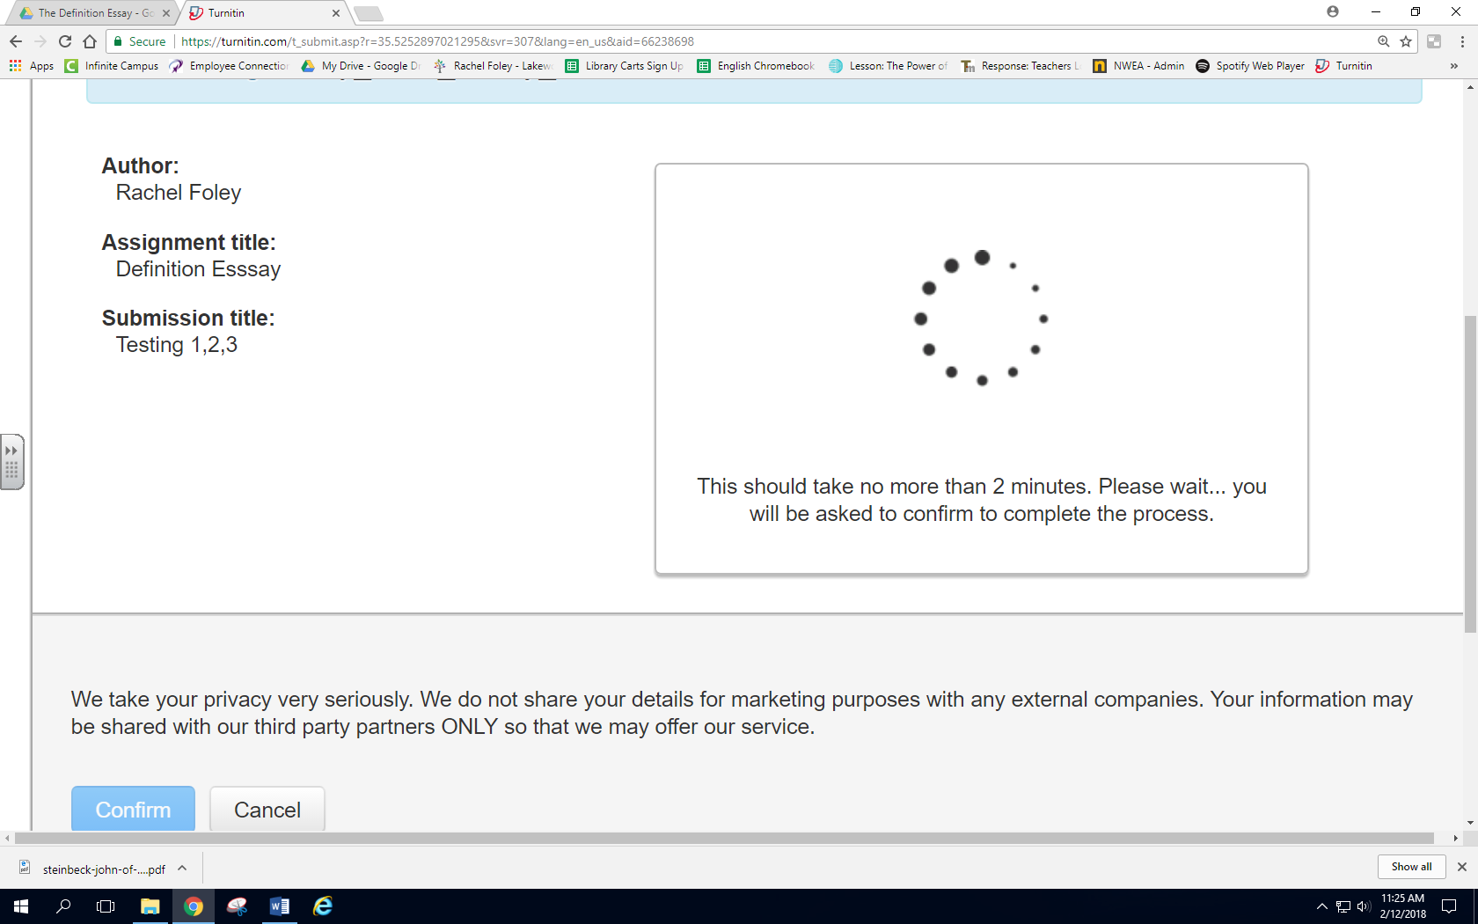

**Submitting an essay**

**Step 8**: YOU ARE NOT FINISHED YET. You must wait until this screen loads to confirm your submission

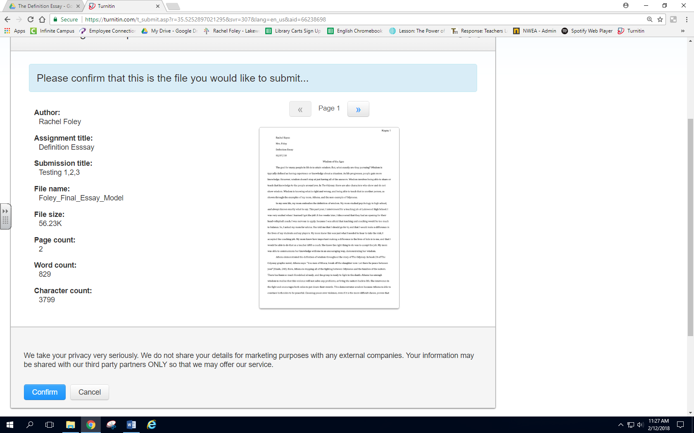

**Submitting an essay**

**Step 9:** When you see this screen, CLICK THE SUBMIT BUTTON. If you do not complete this step, your essay will not be turned in.

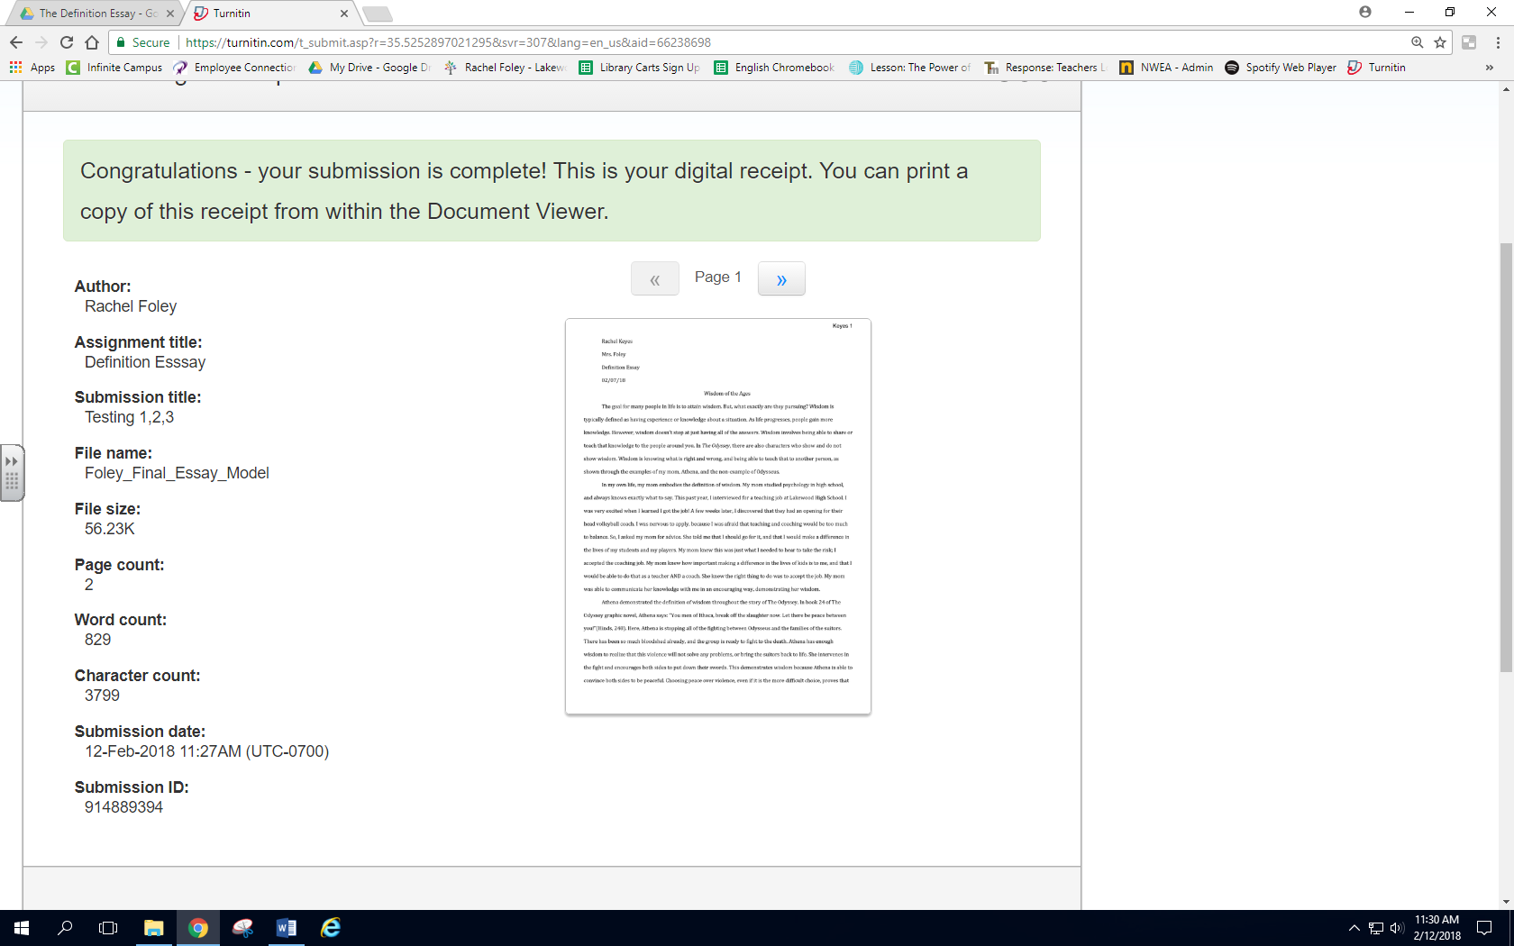

**Submitting an essay**

**Step 9:** When you see this screen, YOU ARE DONE!! Yay!! Your essay has been turned in! You may log out of turnitin.com